What is HTML?

HTML stands for Hyper Text Markup Language
HTML is not a programming language, it is a markup language
A markup language is a set of markup tags
HTML uses markup tags to describe web pages
The Extension of html is .html or .htm.

Software Requirements:
1. Any OS(Operating System).
windows, linux , unix , macintosh, sun solaris.
2. Use any Text editor
Notepad (windows) * it is not an HTML editor
vi editor (linux, unix)
Text Edit for Mac
3. Any web Browser (To view the web pages)
MSIE(IE) -> Microsoft Internet Explorer.
Netscape Navigator
Opera,
Fire Fox, Mozilla, Chrome,safari.
4. Internet Connection (Optional)
5. Any Development tools ( HTML Editors).
(IDEs-Integrated Development Environments)
WYSIWYG (What You See Is What You Get)
Microsoft Visual Interdev
Microsoft Front page.
Adobe GoLive
(Macromedia)-> Adobe Dreamweaver.
use any Text editor
Notepad (windows) * it is not an HTML editor
vi editor (linux, unix)

Html Contains Tags:
What is tag?:
A text that which it was enclosed between '<' and '>'
i.e -> <text>
examples: <html>,<b>,<p>, <bdps>*
There are 2 types of tags.
1. Empty tags:
it has only opening, empty tags will not have any child tags.
Syntax:
<tag_name [attribute1 attribute2 ...]>
Example:
<hr> ->without attributes
<hr color='red' align='center'>
XHTML: <hr />
list of empty tags in HTML :
<hr>, <img>, <input>, <br>, <link>
2. Container tags:
a tag will have both opening, closing,
tags will have body & child tags.
<html>....</html>
<body>....</body>
syntax of the tag
<tag_name [attribute1 attribute2 ...]>
text/tag (body)
</tag_name>
ATTRIBUTE:
What is attribute?
It is an additional information to the tag. which is used overwrite the default values.
Syntax of the Attribute:
attribute_name=attribute_ value
Example:
bgcolor='red'
align='center'
Structure of the HTML Page.
<html>
<head>
----
---- header part (optional)
</head>
<body>
----
---- body part (required)
----
</body>
</html>
header part(optional):
it does not produce any output.
this part is used to pass instruction to the browser or to the search engine.
<title> , <script>, <style> , <meta>, <link>.
body part(required):
everything u have to write in the body.
Basic Rules of HTML:
1. html tags are case insensitive
<html> , <HTML> , <HTml>
2. attribute names are also case insensitive
3. attribute values may be case sensitive
name="sno" value="bdps"
SNO
4. attribute values may be eighter in ' or "
bgcolor=red
bgcolor='red'
bgcolor="red"
alt=this is my photo * invalid
alt="this is my photo"
5. avoid spaces after '<'
< html>
6. avoid spaces with in tags
<h tml>
7. html allows nested tags.
<small>
<small>Bdps Software Ltd</small>
</small>
8. the last openned tag will be closed first.
<b><i><u>BDPS</u></i></b>
9. html pages can be saved with .html / .htm extensions.

Text Tags In HTML:
1.Bold:
<b>,<strong> tags are using for Bold in HTML
<b>------------------------</b>
<strong>-----------------</strong>
2.Italic:
<i>,<em> taga are using for Italic in HTML
<i>---------------------</i>
<em>------------------</em>
3.Underline
<u> tag is using for Underline
<u>------------------</u>
4.Increase the font size:
<big>------------------</big>
5.Decrease the Font size:
<small>------------</small>
6.Strike
<strike>--------</strike> or <s>--------------</s>
7.Subscript
<sub>-----------</sub>
8.Superscript
<sup>-----------</sup>
9.Break
<br>
10.Horizantal Rule
<hr color=”red” width=”value” size=”value”>

HTML COMMENTS :
Comments can be inserted into the HTML code to make it more readable and understandable. Comments are ignored by the browser and are not displayed.
<!-- HTML COMMENT - ->
<html>
<body>
Text formatting tags:<br>
<b>welcome</b><br>
<i>welcome</i><br>
<u>welcome</u><br>
<b><u><i>welcome</i></u></b><br>
<strike>welcome</strike><br>
<s>welcome</s><br>
<big>welcome</big>
<small>welcome</small>
<small>
<small>welcome</small>
</small><br>
subscript: H<sub>2</sub>SO<sub>4</sub><br>
superscript: 2 <sup>nd</sup><br>
Java<sup>TM</sup> <br>
Ranbaxy<sup>&reg;</sup> <br>
&copy; &hearts; &frac12; &frac14; &frac34;
&euro; &Alpha;
</body>
</html>
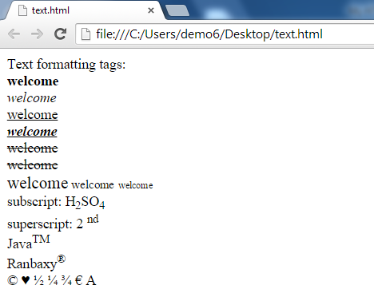
HEADING:
HTML headings are defined with the <h1> to <h6> tags.

<html>
<head>
<title> HTML HEADINGS</title>
<body>
<h1>Welcome to Vijayawadawiki</h1>
<h2 align="center">www.vijayawadawiki.com </h2>
<h3 align="center">www.vijayawadawiki.com </h3>
<h4 align="center">www.vijayawadawiki.com </h4>
<h5 align="center">www.vijayawadawiki.com </h5>
<h6 align="right">www.vijayawadawiki.com </h6>
</body>
</html>
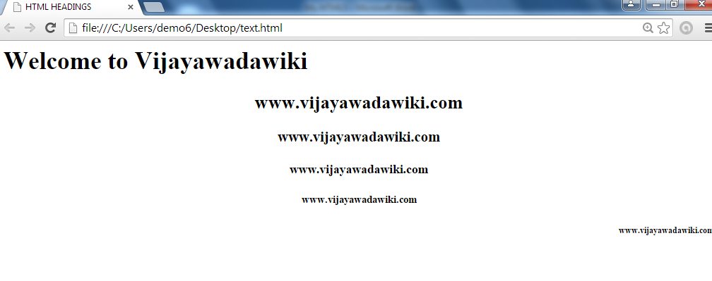

HTML Paragraphs:

HTML paragraphs are defined with the <p> tag.
<html>
<head>
<title> EXAMPLE OF PARAGRAPH </title>
<body>
<p> Notepad is a basic text-editing program and it's most commonly used to view
or edit text files. A text file is a file type typically identified by the .txt file name
extension.You can go to a specific line in a Notepad document even if the document
doesn't display line numbers. Lines are counted down the left margin beginning at
the top of the document.
</p>
</body>
</html>

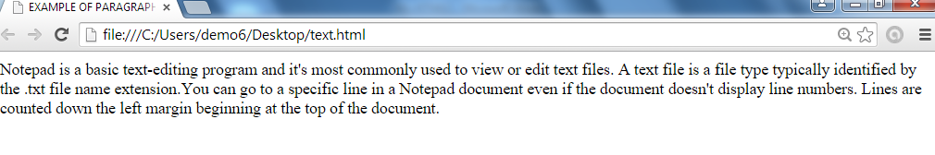

HTML LINKS :
HTML links are defined with the <a> tag.
<html >
<head>
<title>HTML LINKS</title>
</head>
<body>
<a href="http://www.vijayawadawiki.com/" target="_blank"> VIJAYAWADAWIKI HOME </a> <br>
<a href="http://www.vijayawadawiki.com/about-us" target="_blank" > ABOUT-US</a><br>
<a href="http://www.vijayawadawiki.com/contact-us" target="_blank" > CONTACT-US </a><br>
</body>
</html>
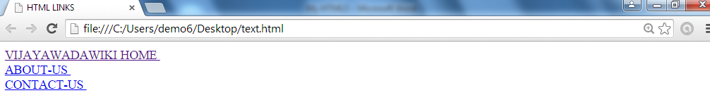

HTML IMAGE :
HTML images are defined with the <img> tag.
<html >
<head>
<title>HTML IMAGE</title>
</head>
<body>
<img src="love.jpg" width="300" height="250" border="1" alt="Alternate Text">
</body>
</html>

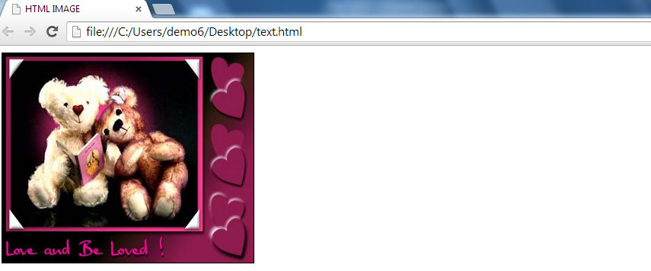

HTML “ Computer Output” Tags :

<code> | Defines computer code text
<kbd> | Defines keyboard text
<samp> | Defines sample computer code
<tt> | Defines teletype text
<var> | Defines a variable
<pre> | Defines preformatted text
<html >
<head>
<title>HTML Computer Output Tags </title>
</head>
<body>
<code> Defines computer code text </code>
<hr/>
<kbd> Defines keyboard text </kbd>
<hr/>
<samp>Defines sample computer code </samp>
<hr/>
<tt> Defines teletype text </tt>
<hr/>
<var> Defines a variable <var>
<hr/>
<pre> I'm Ajay Damraliya !! </pre>
<hr/>
</body>
</html>

HTML Citations ,Quotations, and Defination Tags :

Tag | Description
<abbr> | Defines an abbreviation
<acronym> | Defines an acronym
<address> | Defines contact information for the author/owner of a document
<bdo> | Defines the text direction
<blockquote> | Defines a long quotation
<q> | Defines a short quotation
<cite> | Defines a citation
<dfn> | Defines a definition term

<html >
<head>
<title>HTML Computer Output Tags </title>
</head>
<body>
This <abbr title="EStackoverflow">WebSite</abbr> was founded in 2014.
<hr/>
Can I get this <acronym title="as soon as possible">ASAP</acronym>?
<hr/>
<address>
Written by estackoverflow.com<br />
<a href="estackoverflow.com/contact-us/">Email us</a><br />
Address: Surat<br />
Phone: +9913924879
</address>
<hr/>
<bdo dir="rtl">Here is some Hebrew text!</bdo>
<hr/>
<blockquote>
Here is a long quotation here is a long quotation
here is a long quotation here is a long quotation
here is a long quotation here is a long quotation
here is a long quotation here is a long quotation
here is a long quotation.
</blockquote>
<hr/>
<q>
<hr/>
<cite>Citation</cite>
</body>
</html>

HTML TABLE :

tables are defined with the <table> tag.
A table is divided into rows (with the <tr> tag), and each row is divided into data cells (with the <td> tag). td stands for "table data," and holds the content of a data cell. A <td> tag can contain text, links, images, lists, forms, other tables, etc.

<html>
<body>
<table border="1">
<tr>
<td>HTML</td>
<td>CSS</td>
</tr>
<tr>
<td>JAVASCRIPT</td>
<td>AJAX</td>
</tr>
</table></body>
</html>
HTML Table Tags:

Tag | Description
<table> | Defines a table
<th> | Defines a table header
<tr> | Defines a table row
<td> | Defines a table cell
<caption> | Defines a table caption
<colgroup> | Defines a group of columns in a table, for formatting
<col /> | Defines attribute values for one or more columns in a table
<thead> | Groups the header content in a table
<tbody> | Groups the body content in a table
<tfoot> | Groups the footer content in a table

HTML LISTS:

The most common HTML lists are ordered and unordered lists.

An ordered list:  1. The first list item  2. The second list item  3. The third list item | An unordered list:  - List item  - List item  - List item
HTML Unordered Lists
An unordered list starts with the <ul> tag. Each list item starts with the <li> tag.
The list items are marked with bullets (typically small black circles).

<ul type=”circle|square|disc”>
<html>
<head>
<title> Unordered List </title>
</head>
<body>
<ul>
<li>C</li>
<li>C++</li>
<li>JAVA</li>
</ul>
</body>
</html>

HTML Ordered Lists
An ordered list starts with the <ol> tag. Each list item starts with the <li> tag.
The list items are marked with numbers
<ol type=”1 | i | a | A | I “>
<html>
<head>
<title> ordered List </title>
</head>
<body>
<ol>
<li>C</li>
<li>C++</li>
<li>JAVA</li>
</ol>
</body>
</html>

HTML Definition Lists
A definition list is a list of items, with a description of each item.
The <dl> tag defines a definition list.
The <dl> tag is used in conjunction with <dt> (defines the item in the list) and <dd> (describes the item in the list)

<html>
<head>
<title> Definition Lists </title>
</head>
<body>
<dl>
<dt>C</dt>
<dd>-C Programming Language</dd>
<dt>C++</dt>
<dd>- C++ Programming !</dd>
</dl>
</body>
</html>
HTML List Tags :

Tag | Description
<ol> | Defines an ordered list
<ul> | Defines an unordered list
<li> | Defines a list item
<dl> | Defines a definition list
<dt> | Defines an item in a definition list
<dd> | Defines a description of an item in a definition list

HTML FORMS :
HTML forms are used to pass data to a server.
A form can contain input elements like text fields, checkboxes, radio-buttons, submit buttons and more. A form can also contain select lists, textarea, fieldset, legend, and label elements.
The <form> tag is used to create an HTML form:

<form>

. input elements .

</form>

HTML Forms - The Input Element :

The most important form element is the input element.
The input element is used to select user information.
An input element can vary in many ways, depending on the type attribute. An input element can be of type text field, checkbox, password, radio button, submit button, and more.
The most used input types are described below.

1.Text Fields :

<input type="text" /> defines a one-line input field that a user can enter text into:
Example :
<html>
<head>
<title>INPUT FORM</title>
</head>
<body>
<form>
First name: <input type="text" name="fname" /><br />
Last name: <input type="text" name="lname" />
</form>
</body>
</html>

2.Password Field
<input type="password" /> defines a password field:

<html>
<head>
<title>Password Field</title>
</head>
<body>
<form>
Enter password: <input type="password" name="pass" /><br />
</form>
</body>
</html>
3.Radio Buttons
<input type="radio" /> defines a radio button. Radio buttons let a user select ONLY ONE one of a limited number of choices:

<html>
<head>
<title>Radio Button</title>
</head>
<body>
<form>
<input type="radio" name="sex" value="male" /> Male<br />
<input type="radio" name="sex" value="female" /> Female</form>
</body>
</html>

4.Checkboxes
<input type="checkbox" /> defines a checkbox. Checkboxes let a user select ONE or MORE options of a limited number of choices.

<html>
<head>
<title>Check Box</title>
</head>
<body>
<form>
<input type="checkbox" name="lang" value="c" /> C<br />
<input type="checkbox" name="lang" value="cpp" /> C++
</form>
</body>
</html>
5.Submit Button :
<input type="submit" /> defines a submit button.
A submit button is used to send form data to a server. The data is sent to the page specified in the form's action attribute. The file defined in the action attribute usually does something with the received input:
<html>
<head>
<title>SUBMIT BUTTON </title>
</head>
<body>
<form name="input" action="check.php" method="get">
Enter Username: <input type="text" name="user_name" /><br/>
<input type="submit" value="Submit" />
</form>
</body>
</html>
6. Drop Down List

<select name=”name”>
<option>--------</option>
<option>-------</option>
</select>

7.Text Area

<textarea rows=5 cols=4></textarea>

HTML Form Tags :

Tag | Description
<form> | Defines an HTML form for user input
<input /> | Defines an input control
<textarea> | Defines a multi-line text input control
<label> | Defines a label for an input element
<fieldset> | Defines a border around elements in a form
<legend> | Defines a caption for a fieldset element
<select> | Defines a select list (drop-down list)
<optgroup> | Defines a group of related options in a select list
<option> | Defines an option in a select list
<button> | Defines a push button

HTML FRAMES :
• With frames, you can display more than one HTML document in the same browser window. Each HTML document is called a frame, and each frame is independent of the others.
• The disadvantages of using frames are:
• Frames are not expected to be supported in future versions of HTML Frames are difficult to use. (Printing the entire page is difficult).
• The web developer must keep track of more HTML documents

The HTML frameset Element
The frameset element holds one or more frame elements. Each frame element can hold a separate document.
The frameset element states HOW MANY columns or rows there will be in the frameset, and HOW MUCH percentage/pixels of space will occupy each of them.
The HTML frame Element
The <frame> tag defines one particular window (frame) within a frameset.

<html>
<frameset rows="20%,60%,20%" border="5">
<frame src="head.html" />
<frameset cols="20%,*" >
<frame src="side.html" />
<frame src="content.html" />
<frameset rows="*,20%">
<frame src="footer.html/>
</frameset>
</frameset>
</frameset>
</html>

Head.html <html>
<head>
<title> Head </title>
</head>
<body>
<h3>WELCOME TO ESTACKOVERFLOW </h3>
</body>
</html>
Side.html
<html>
<h2> HOME </h2>
<h2> ABOUT </h2>
<h2> CONTACT </h2>
<h2> LOGIN </h2>
</html>

Content.html
<html>
<body>
<p> I'm Ajay Damraliya </p>
</body>
</html>

Footer.html

<p> Copyright By Ajay </p>

HTML Frame Tags :

Tag | Description
<frameset> | Defines a set of frames
<frame /> | Defines a sub window (a frame)
<noframes> | Defines a noframe section for browsers that do not handle frames

HTML IFRAMES :
• An iframe is used to display a web page within a web page.

Syntax for adding an iframe:

<iframe src="URL">
</iframe>
Iframe - Set Height and Width
• The height and width attributes are used to specify the height and width of the iframe.
• The attribute values are specified in pixels by default, but they can also be in percent (like "80%").

<html>
<head>
<title> Ifrmae </title>
</head>
<body>
<iframe src="about.html" width="100%" height="300">
<p>Your browser does not support iframes.</p>
</iframe>
</body>
</html>

about.html
<html>
<head>
<title> ABOUT AJAY </title>
</head>
<body>
I'm Ajay
</body>
</html>

HTML CANVAS GRAPHICS:
The HTML <canvas> element is used to draw graphics on a web page.

The graphic to the left is created with <canvas>. It shows: four elements: a red rectangle, a gradient rectangle, a multi color rectangle and a multicolor text.

What is HTML Canvas?
The HTML <canvas> element is used to draw graphics, on the fly, via Java Script.

The <canvas> element is onlt a container for graphics. You must use java script to actually draw the graphics.

Canvas has several methods for drawing paths, boxes , circles, text, and adding images.

<!DOCTYPE html>
<html>
<body>

<canvas id="myCanvas" width="500" height="300" style="border:3px solid #d3d3d3;">
Your browser does not support the HTML canvas tag.</canvas>

<script>
var c = document.getElementById("myCanvas");
var ctx = c.getContext("2d");
ctx.moveTo(50,30);
ctx.lineTo(400,400);
ctx.stroke();
</script>

</body>
</html>
